 EXECUTIVE PROPERTY MANAGEMENT GROUP
______________________________________________________
1751 MOUND STREET, SUITE 206 SARASOTA, FL 34236
OFFICE- 941-365-0200 CELL- 941-809-7027 FAX- 941-365-0290
GARYLANDSMAN@COMCAST.NET

PRIME RETAIL SPACE FOR LEASE
PALMA SOLA SHOPPING CENTER
55th St.- 59th St. and MANATEE AVENUE WEST BRADENTON, FL
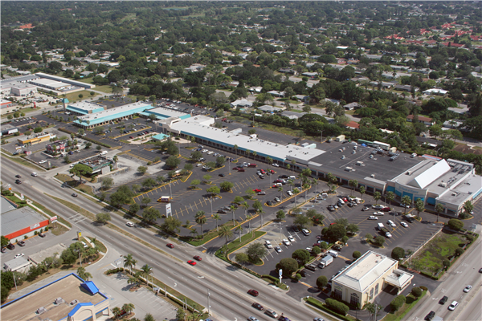

The single most visible & best located shopping center in the strongest demographic location in West Bradenton.

Manatee Avenue West (State Road 64) is Bradenton’s busiest retail street and is the major East-West artery between Downtown Bradenton and Anna Maria Island, Holmes Beach, Bradenton Beach & Longboat Key

Palma Sola Square runs from 55th to 59th streets with over 1,300 feet of frontage on Manatee Ave.
Center on 14.4 acres with parking for 700 parking cars

Join Winn Dixie Supermarket, Sprint, Honey Baked Ham, Cross Fit Training, the prestigious Dance Theater of Bradenton, the YMCA, Siam Thai Restaurant (top Yelp rated!), Josef’s Coiffures, You Never Know consignment shop, D’Vine Touch, as well as outparcel occupants: Starbucks, Tires Plus, BMO Harris Bank, Dunkin’ Donuts and Hancock Bank.

Nearby on Manatee Avenue West: Fresh Market, Publix, Planet Fitness, Bealls Outlet, Dollar General, Firehouse Subs, Atlanta Bread, Five Guys Burgers, McDonald's, Fifth Third Bank, Edible Arrangements, Verizon, Pizza Hut, Iberia Bank, K-Mart, Staples, C1 Bank, Pet Supermarket, Midas and a 2nd Bealls Outlet.

The following video and photographic “tours” of Palma Sola Square will give you an excellent sense of the layout and functionality of this property and the surrounding neighborhood:

http://www.iplayerhd.com/player/2bc3014b-c5ff-4819-b1dd-a2ec926188cc

https://collab.dronebase.com/m/685cfed1ab34b652076397669b2d5065/v/8356

5505-5805 Manatee Avenue West B.mp4

Please feel free to contact me at your earliest convenience for an appointment to see what we have to offer at the Palma Sola Square Shopping Center. At the same time we can discuss any questions you might have about the property, buildings, rental spaces or lease and you can assess the advantages of locating your business in this vibrant shopping center that will serve to invigorate your employees and customers in your beautiful new space.

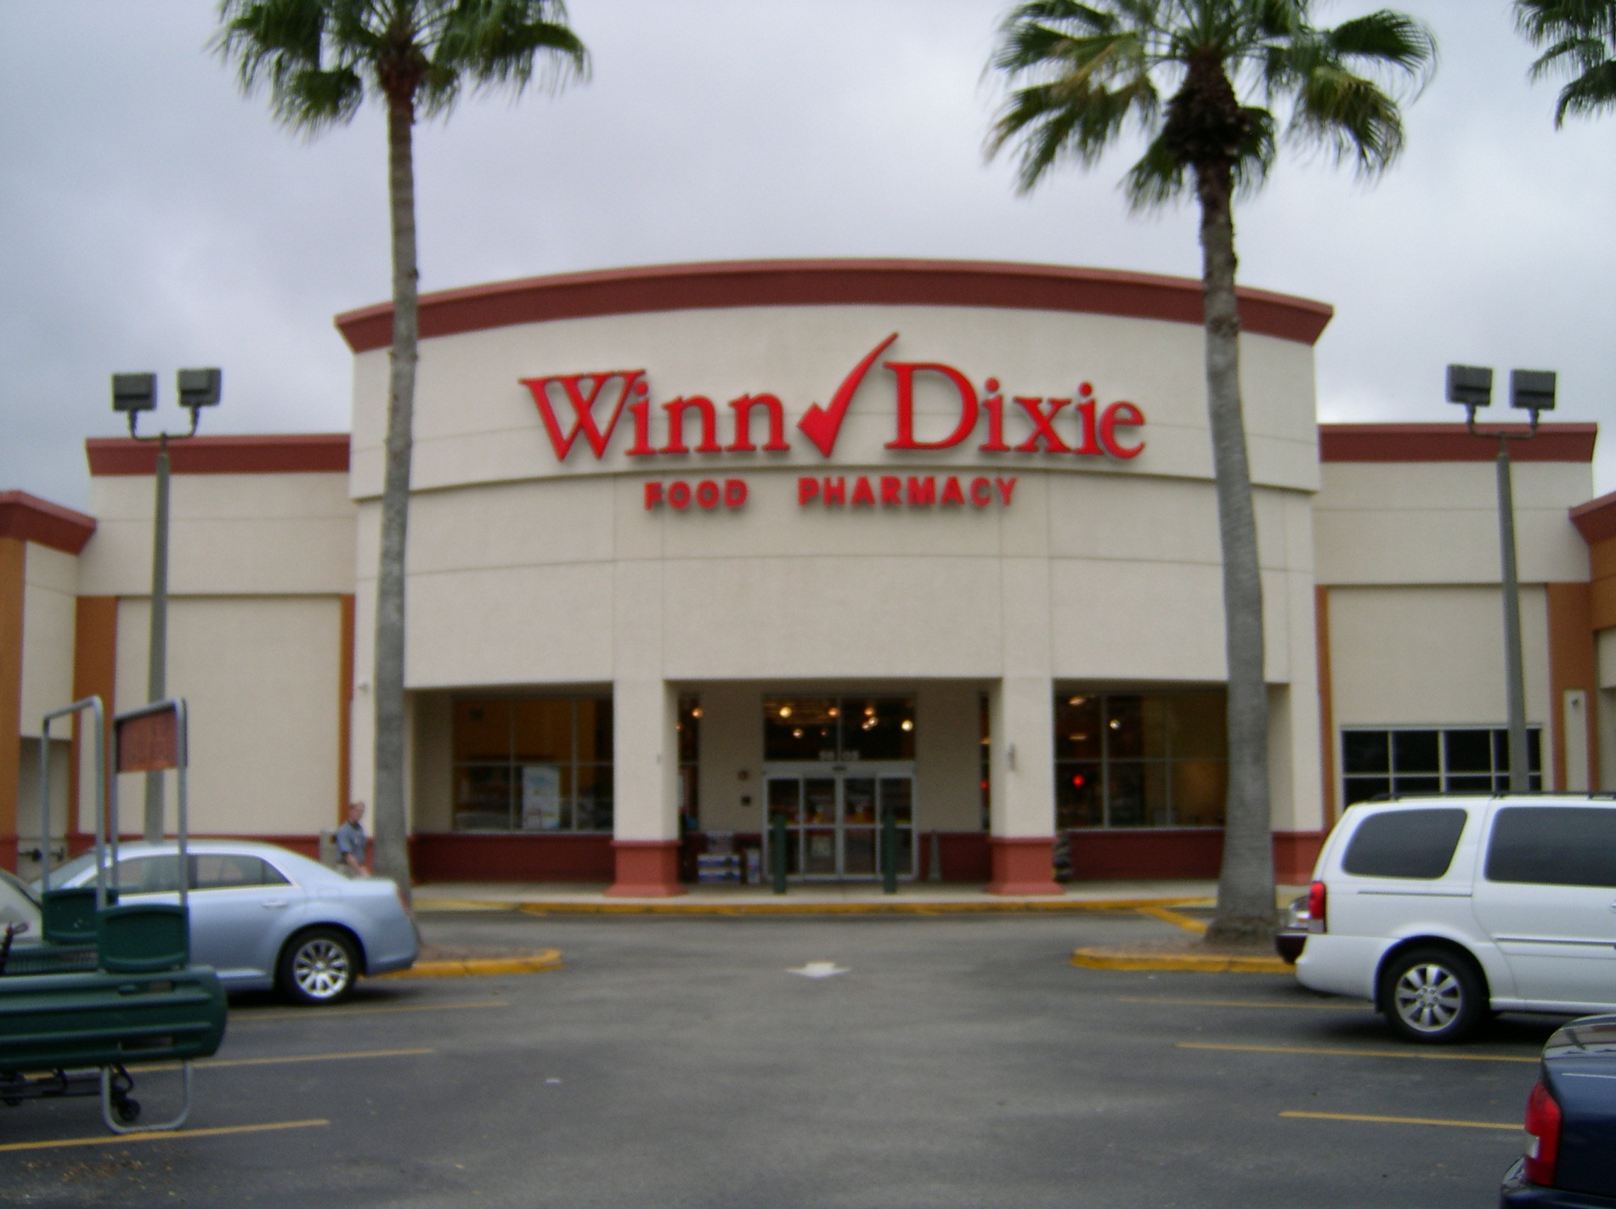

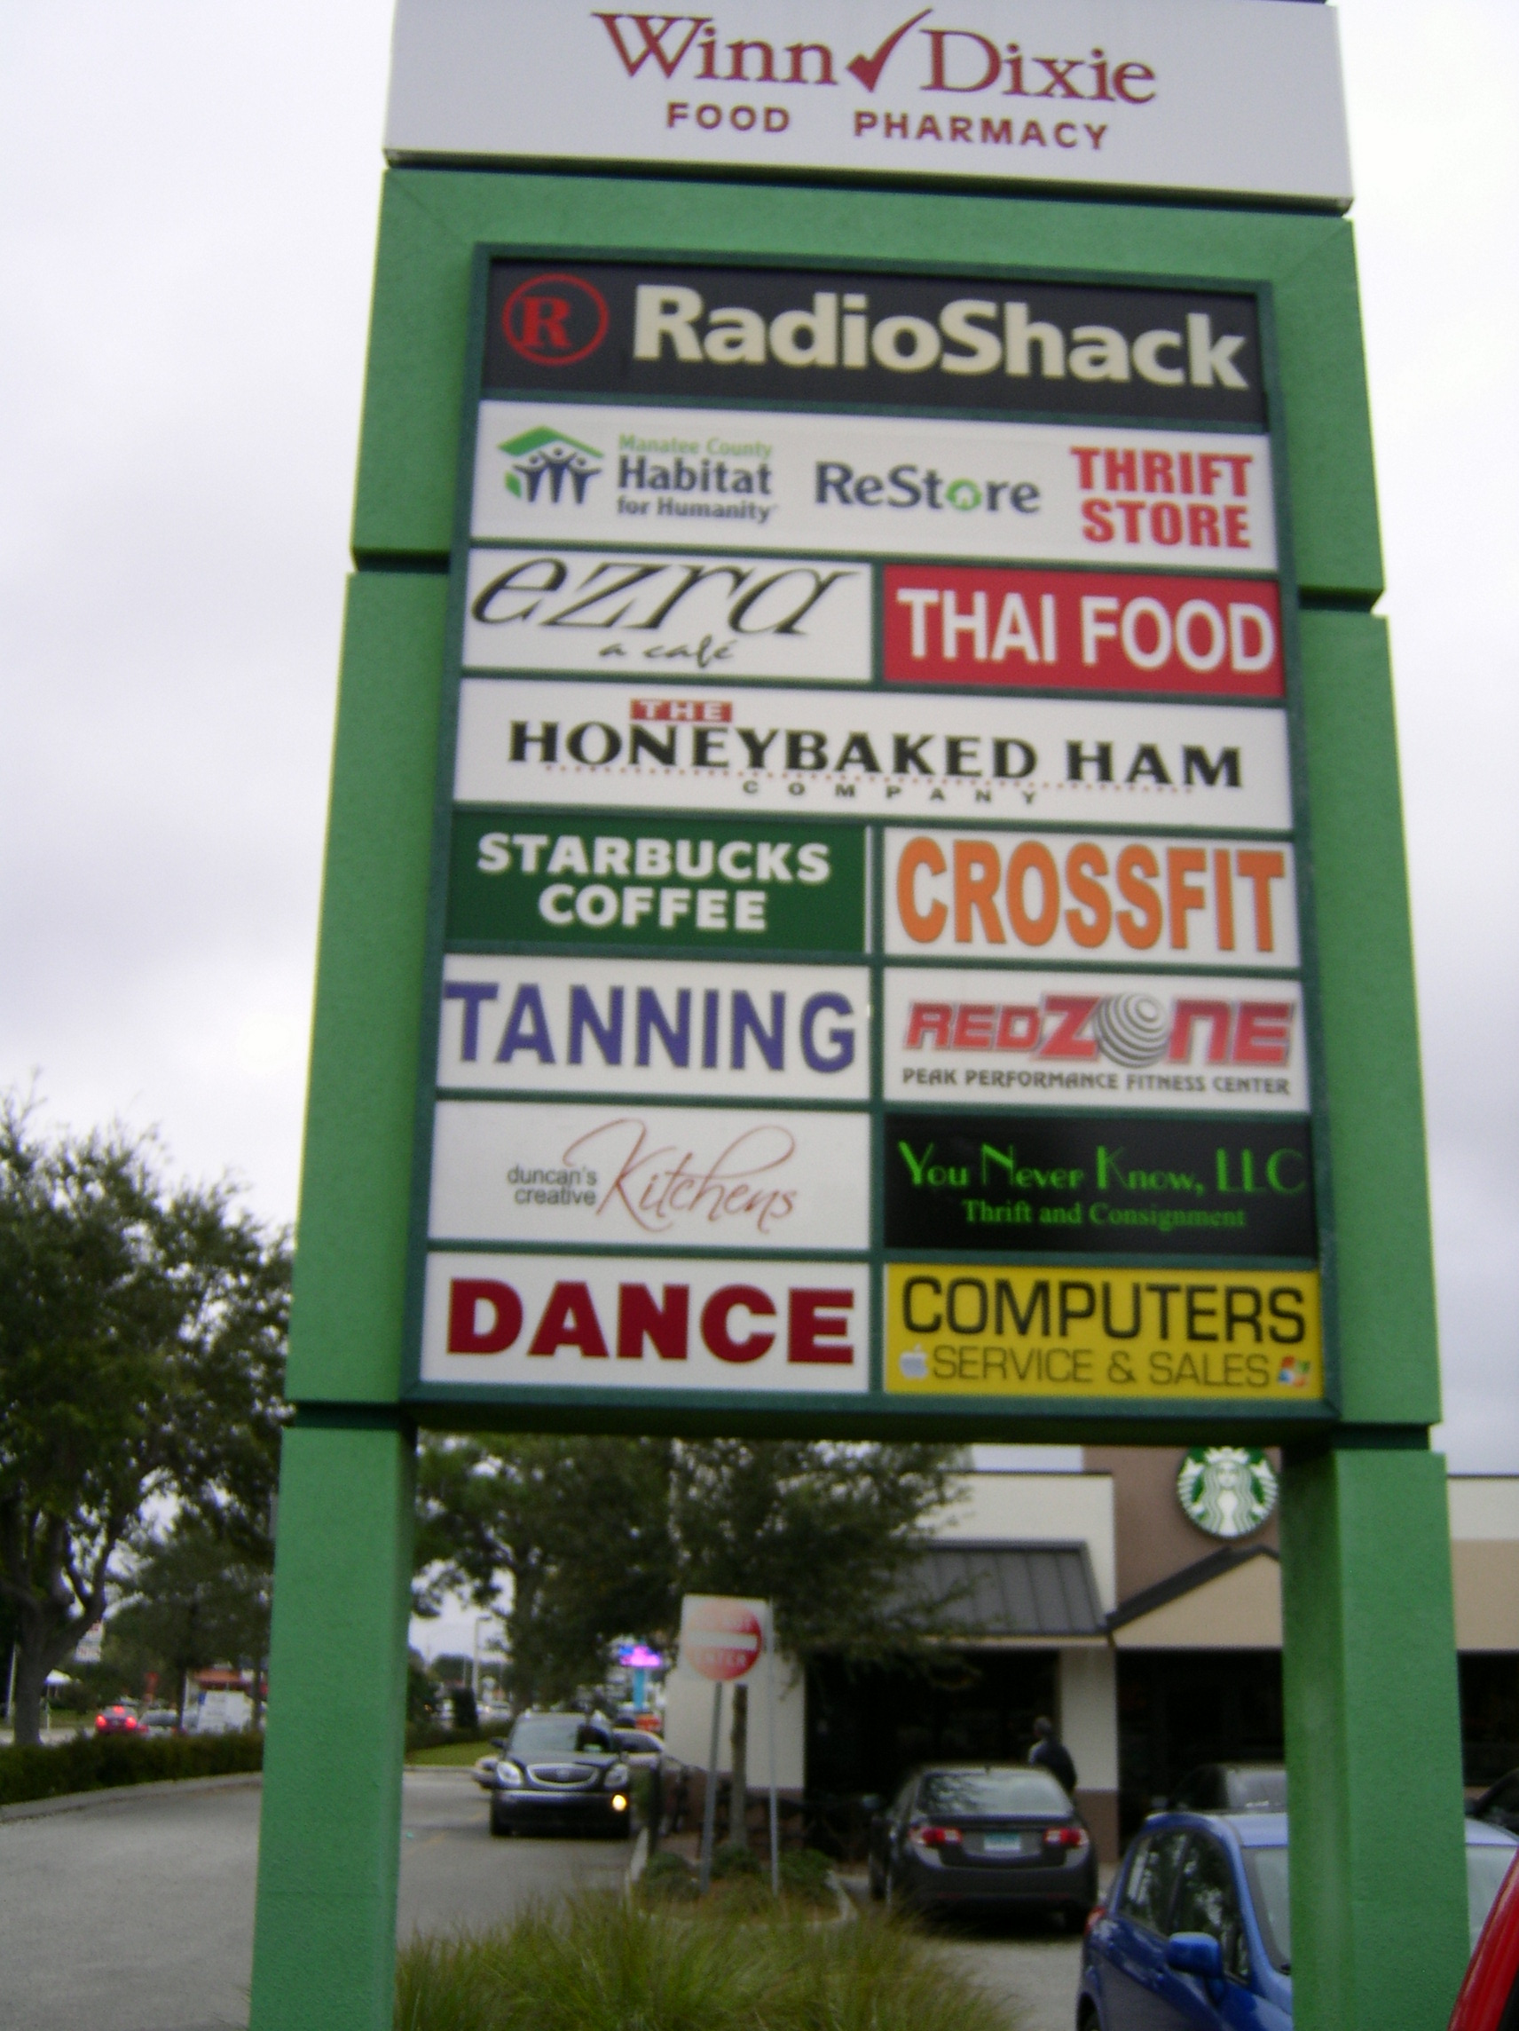

Contact: Gary Landsman at Executive Property Management Group,
Ofc.- 941-365-0200; Cell- 941-809-7027
garylandsman@comcast.net
Brokers invited, welcome & protected

